Hamza Irshad

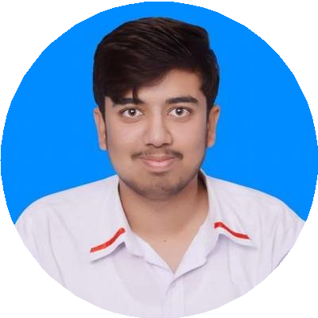

[hamzairshad625@yahoo.com](mailto:hamzairshad625@yahoo.com) 

03369265425 

Islamabad, Pakistan

To succeed in an environment of growth and excellence and earn a job which provides me job satisfaction and self-deployment and help me achieve personal as well organizational goals. I want to create value and recognition on workplace by producing the best result for organization through synchronization and hard work.

# WORK EXPERIENCE

## Internship in Accounts and Audit Departement



### PINSTECH

*01/2021 - 03/2021*, *Islamabad, Pakistan Government Institute*

*Achievements/Tasks*

Learned how the organization deals with the case of house hiring, Medical Bills. And how the procurement department work and steps are procedures to follow before buying any product/machinery

## Accounts and Taxation Assistant

### Financial Tax Consulting (C&MA)

*10/2019 - 10/2020*, *Islamabad, Pakistan Achievements/Tasks*

Records keeping & Book Keeping

File handling - FBR IRIS ﬁling if income and Sales Tax Corporate Matters and Audit and Assurance Dealing with SECP Maters (Registration of ﬁrm etc.)

## Internship

### Toyota Islamabad Motors

**SKILLS**

Tax Compliance

Bookkeeping

#### 

Financial Modelling

Tax Advisory

Tax Planning

Financial Reporting

Analytical Ability

Problem Solving Skills

Commercial Acumen

Quickbooks

**ACHIEVEMENT**

Participation in Air Tech 2018 and 2019

*Member of Marketing and Sponsorship Team*

# CERTIFICATE

#### MS Oﬃce (07/2015 - 01/2016)

*AGT Institute of Technical And Professional Education*

# LANGUAGES

*07/2019 - 08/2019*, *Islamabad, Pakistan Achievements/Tasks*

Check and balance of day to day activities and

operations within department

Salary Making, Allowances, Dealing with advance salary matters, File handling and record-keeping

## Customer Relation Oﬃcer

### Telenor

*05/2018 - 09/2018*, *Islamabad, Pakistan*

English

*Full Professional Proﬁciency*

Pashto

*Professional Working Proﬁciency*

# INTERESTS

Software Automation

Business Study

Urdu

*Native or Bilingual Proﬁciency*

Hindko

*Full Professional Proﬁciency*

## Customer's Sales Representative

Book Reading

### Calling Tech

*09/2016 - 11/2016*, *Islamabad, Pakistan*

# EDUCATION

## Bachelor in Accounting and Finance



### Air University

*08/2017 - Present*, *Islamabad, Pakistan*

## Higher Secondary School Certiﬁcate

### Institution/Place of Education

*07/2017*,

## Secondary School Certiﬁcate

### Institution/Place of Education

*04/2014*,